CS 4470: Artificial Intelligence
HW1

Points: Please see the points for each problem. Instruction: Please submit on canvas

- It is a training day for a swarm of robotic miners in a hazardous environment. Each of the k miners starts in its own assigned start location si in a large maze of size M × N, meaning M columns and N rows. Each miner’s goal is to return to its own dumpsite stationed at location gi. Along the way the miners must gather all chucks of Strontium 90 (think Pacman dots) in the maze.

At each time step, all k miners move one unit to any open adjacent square. The only legal actions are Up, Down, Left, or Right. It is illegal for a miner to wait in a square, attempt to move into a wall, or attempt to occupy the same square as another miner. To set a record, the miners must find an optimal collective solution.
  - (3 pts) Define a minimal state space representation for this problem.
    - State = (P, C) where P is a tuple of the position of each miner and C is a set of the remaining chunks
    - All we need is P and C because it is the lowest amount of information needed to describe the space, no need to track steps or goals,etc.
  - (3 pts) How large is the state space?
    - ((MN)!/(MN – k)!) * 2^r
    - Because no 2 miners can be in the same spot, we calculate the total number of ways a miner can choose based on k distinct positions. Therefore, MN!/MN-k!. Each chunk can either be collected or not, therefore there are two more choices so we multiply the miner step permutation by 2^r where r is the number of chunks available.

- Consider the search graph shown below. S is the start state and G is the goal state. All edges are bidirectional.

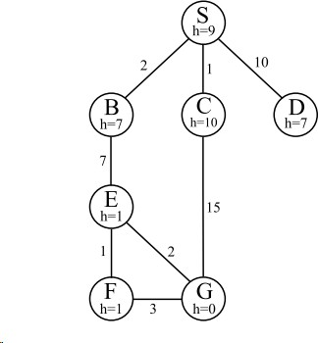
For each of the following search strategies, give the path that would be returned, or write none if no path will be returned. If there are any ties, assume alphabetical tiebreaking (i.e., nodes for states earlier in the alphabet are expanded first in the case of ties).

- (3 pt) Depth-first graph search
DFS explores as far as possible before backtracking, prioritizing alphabet.

S, B, E, F, G

- (3 pt) Breadth-first graph search
BFS explores all nodes at that depth before moving on
S, C, G

- (3 pt) Uniform cost graph search
Lowest path cost.
S, B, E, G

- (3 pt) Greedy graph search
Lowest node cost.
S, B, E, G

- (3 pt) A* graph search
Node and taking path into consideration.
S,B,E,G

